Intermolecular relaxation in liquids as revealed by FC ¹H NMR relaxometry- dilution experiments
R. Meier, D. Kruk⁺, J. Gmeiner, E.A. Rössler*

Experimentalphysik II, Universität Bayreuth, 95440 Bayreuth, Germany
⁺ permanent address: Institute of Physics, Jagiellonian University, Reymonta 4, 30-059 Krakow, Poland
*corresponding author

Abstract
¹H spin-lattice relaxation rates R₁ = 1/T₁ have been measured for glycerol-h₅ diluted in glycerol-h₀ for progressively lower concentrations of glycerol-h₅ (100% - 22%). By means of the field cycling (FC) technique relaxation dispersion data R₁(ω) have been collected for several temperatures in a frequency range of 10 kHz – 20 MHz. In order to disclose the spectral shape of the intermolecular relaxation, extrapolation of the relaxation data to the zero concentration limit has been performed. The result shows that the intermolecular dipole-dipole interactions (being the source of the intermolecular relaxation) fluctuate in time due to translational as well as rotational motion. The influence of the molecular rotation is considerable due to non-central positions of the interacting nuclei. This eccentricity effect is quantitatively reproduced by treating the intermolecular spectral density as a sum of translational-like (described by the free diffusion model) and rotational-like contributions (described by a Cole-Davidson function). Applying frequency-temperature superposition NMR master curves as well as individual R₁(ω) data are analyzed within this approach, and the translational diffusion coefficient D(T) can be extracted in spite of the rotational influence.

1. Introduction
In recent years field cycling (FC) nuclear magnetic resonance (NMR) relaxometry has become a powerful tool for investigating dynamics in condensed matter.¹ Due to availability of commercial FC spectrometers this technique gained new momentum. Field cycling ¹H NMR allows routine measurements of spin-lattice relaxation time dispersion T₁ = T₁(ω) in a frequency range of 10 kHz to 20 MHz.
In our two recent publications we have compared the results of ¹H NMR relaxometry and dielectric spectroscopy (DS) for several viscous liquids.^{2,3} It is well known that DS spectra for such systems can be described in terms of a Cole-Davidson (CD) spectral density providing correlation times of the reorientational dynamics involved in the structural relaxation (α–process) which is determined by the glass transition phenomenon.^{4, 5} ¹H NMR susceptibility spectra, i.e., relaxation dispersion data transformed to the susceptibility representation, show, in addition to the α–relaxation peak, a low-frequency excess contribution (a kind of a shoulder) the amplitude of which varies for different liquids. In our last contribution³, we have attributed this low-frequency process to intermolecular relaxation mediated by translational motion of the molecules, while the main relaxation peak originates from intramolecular relaxation associated with reorientational dynamics. As ¹H NMR relaxation probes fluctuations of dipole-dipole (DD) interactions between pairs of protons, one has to distinguish between proton sites within the same molecule (intramolecular) and in different molecules (intermolecular). Thus, the overall relaxation rate 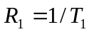 is a sum of intramolecular and intermolecular relaxation rates, 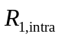 and 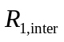, respectively. It is expected that the intermolecular relaxation is dominated by the relative translational motion of the spins located on different molecules.
Assuming a CD susceptibility for the intramolecular part reflecting reorientational dynamics, while the intermolecular part of the overall ¹H relaxation rate R₁(ω) has been described by the force-free-hard-sphere model ^{6,7}, i.e., Fick diffusion with appropriate boundary conditions, we have been able to quantitatively describe the T₁ dispersion data for differently deuterated glycerol over a large temperature range.³ Thereby, we have extracted values of the diffusion coefficient, D(T). The values obtained are in good agreement with those from pulse field gradient NMR. ^{8, 9} This shows that FC ¹H NMR has the potential to become an alternative method of measuring diffusion coefficients in liquids. Here, we note that a similar analysis has already be attempted by Kintzinger and Zeidler. ¹⁰ The authors pointed out that describing the intermolecular relaxation of glycerol in terms of the Torrey´s jump model of translation diffusion ¹¹ to the glycerol one gets values of the diffusion coefficients which are larger than those independently measured. The jump model is now believed to be less applicable for liquids as compared to the force-free-hard-sphere model mentioned above.
The above outlined interpretation of FC ¹H NMR dispersion data of simple liquids relies on the fact that the intra- and intermolecular relaxation contributions exhibit distinct dispersion features i.e., they are spectrally shifted. For the hydrodynamic model of a (molecular) sphere rotating and translating in a viscous medium Abragam ¹² derived the relationship τ_{trans}/τ_{rot} = 9, where τ_{trans} is the correlation time of translational diffusion and τ_{rot} = τ_{α} is the rotational correlation time that can be identified with the time constant of the α–process. Experimentally, we have observed τ_{trans}/τ_{rot} = 30 – 60.³ This ratio is essentially temperature independent as expected for translational-rotational coupling to hold for moderately viscous liquids. ¹³
Yet, the ultimate proof of our approach can only be given if one is able to separate the intra- and intermolecular relaxation in a model free way. This is usually done by performing so-called isotope dilution experiments.^{14,15,1617,18} Substituting protonated molecules by their deuterated counterpart allows suppressing the intermolecular dipole-dipole interactions. Then by extrapolating the results to the infinite dilution limit one can isolate the intramolecular relaxation for a given frequency and temperature, thereby obtaining the intermolecular part. Up to our knowledge, such experiments have been rarely performed by FC ¹H NMR.^{10,19} In the present contribution we use isotope dilution to separate intra- and intermolecular relaxation in the glass former glycerol. As it will be demonstrated, because the interacting protons belonging to different molecules are not placed in the molecular center the intermolecular relaxation is also affected by molecular rotation. This is referred to as the eccentricity effect.²⁰ Thus, the intermolecular relaxation is influenced by both translational and rotational motion. In the simple diffusion model mentioned above the eccentricity effect is not taken into account. In other words, it is assumed that the protons are in the center of a (spherical) molecule treated as a hard sphere. The eccentricity has been discussed in the literature, ^{20,21,22}, however, no systematic studies have been performed, so far. In this work we explicitly show the combined effects of the translational and rotational motions on the intermolecular relaxation. The translational diffusion coefficient can be extracted from the relaxation dispersion results in spite of the rotational influence.

2. Relaxation theory for isotopically diluted systems
A description of ¹H spin-lattice relaxation for non-deuterated and partially deuterated liquids has been given in Ref. ³. Here we shall extend it to the case when a partially deuterated (or non-deuterated) liquid is diluted in its fully deuterated counterpart, for instance glycerol-h₈/glycerol-h₀, or glycerol-h₅/glycerol-h₀. As already explained, the observed relaxation rate, 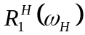 (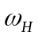 denotes the proton angular frequency) is a sum of intramolecular, 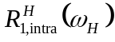, and intermolecular, 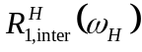, contributions, i.e.:

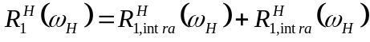 (1)

For partially deuterated molecules the intramolecular as well as intermolecular relaxation results from ¹H-¹H (HH) and ¹H-²H (HD) dipole-dipole interactions; that means:

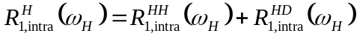 (2a)
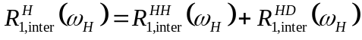 (2b)
The ¹H-¹H relaxation contributions are expressed as the well-known combination of spectral densities for a system of two equivalent spins with corresponding proportionality constants:
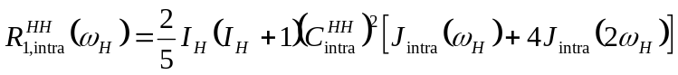 (3a)
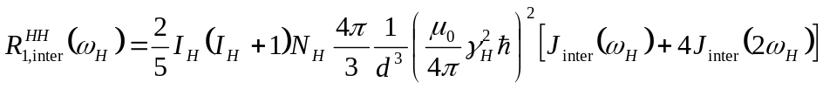 (3b)
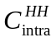 denotes an effective intramolecular dipole-dipole (DD) coupling constant, 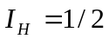, 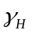 is the proton gyromagnetic ratio, other symbols have their obvious meaning. The parameter 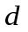 (Eq. 3b) is the distance of closest approach of the interacting nuclei (for identical molecules 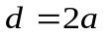, where is the molecular radius), while 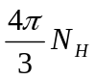 is the number of protons per unit sphere. The intramolecular spectral density, 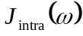, reflects rotational dynamics of the molecules. For viscous liquids one typically assumes a CD form of the susceptibility function 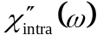 related to as 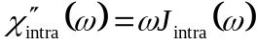, i.e.: ²³
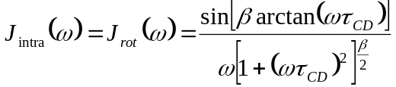 (4)
where 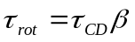 is the rotational correlation time, while 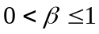 is a phenomenological stretching parameter. In Ref. ³ the intermolecular spectral density, 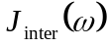, reflecting the translational motion has been described according to the model proposed by Hwang and Freed ⁶ and Ayant et al. ⁷ as hard spheres with the nuclei of interest assumed to be placed in their centers. In consequence, the following form of has been used ^{24,25}:
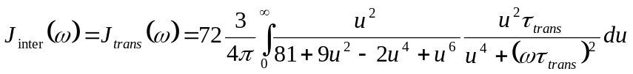 (5)
with 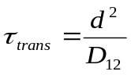, where 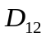 is the relative translational diffusion coefficient defined as a sum of self-diffusion coefficients of the participating molecules (for identical molecules 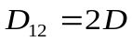). We note that and are normalized, i.e., 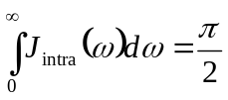. As already explained in the Introduction the assumption that the interacting nuclei (spins) are placed in the center of the molecule implies that the fluctuations of the intermolecular vector (in terms of its orientation and length) are entirely caused by the translational motion. However, for polyatomic molecules with nuclei placed at different positions in the molecule the fluctuations of the intermolecular DD interactions are also mediated by rotational dynamics (besides the translational motion).

The ¹H-²H contributions to the intra- and intermolecular relaxation are given as:
(6a)
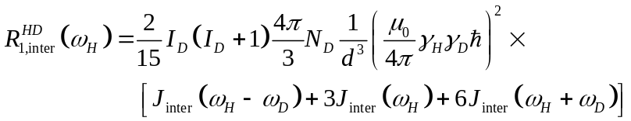 (6b)

where 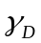 and 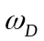 are the deuteron gyromagnetic factor and the deuteron Larmor frequency, respectively and 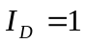, while 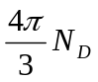 is the number of deuterons per unit sphere.
Let us now consider a partially deuterated liquid (for example glycerol-h₅) mixed with its fully deuterated counterpart (glycerol-h₀ in this case). Combining the invoked expressions for intramolecular and intermolecular relaxation rates, one gets the following expression for the overall ¹H spin-lattice relaxation rate:
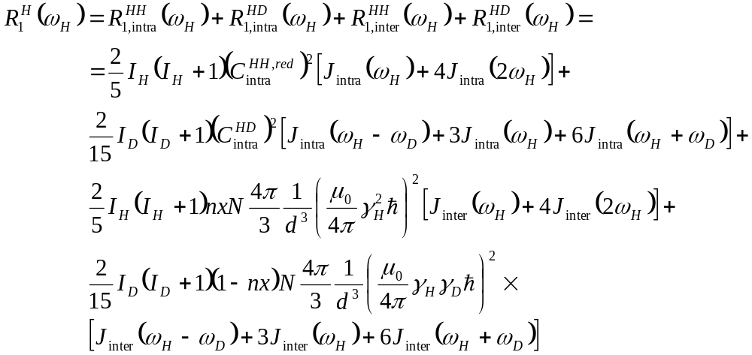 (7)
The factor denotes the fraction of protons in the molecule (for instance 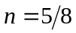 for glycerol-h₅), thus (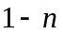) is the fraction of deuterons, while is the mole fraction of molecules which contain ¹H (not fully deuterated molecules). For  this expression is identical with Eq. 15 of Ref.³; 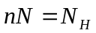 and 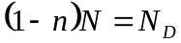. The dilution (reflected by the factor ) obviously affects only the intermolecular relaxation. The intramolecular part remains unchanged. The meaning of 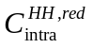 has already been explained in Ref. ³; it is a reduced DD coupling after accounting for partial deuteration of the molecule. In the case of isotopic dilution the ¹H-²H contribution to the intermolecular relaxation is reduced by the fraction , i.e. , while the ¹H-²H contribution is weighted by the factor 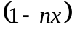. For example, let us consider a reference ¹H nucleus. The intermolecular ¹H-²H contribution stems from its interactions with ²H nuclei of the partially deuterated molecules and of the fully deuterated molecules. The first contribution is now weighted by the factor 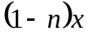 and the second one by 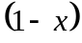; summing them up one gets appearing in the fourth term of Eq. (7).
To analyze the intermolecular contribution to the overall relaxation as a function of let us assumed that 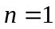. This means that we consider a system containing a fraction of fully protonated molecules and of fully deuterated molecules. Fig. 1 shows simulations of ¹H spin-lattice relaxation rates versus for a set of parameters suiting well to the case of glycerol-h₈/glycerol-h₀ (parameters for glycerol have been obtained in Ref. ³). For  the intermolecular contribution stems entirely from ¹H-²H dipole-dipole interactions.
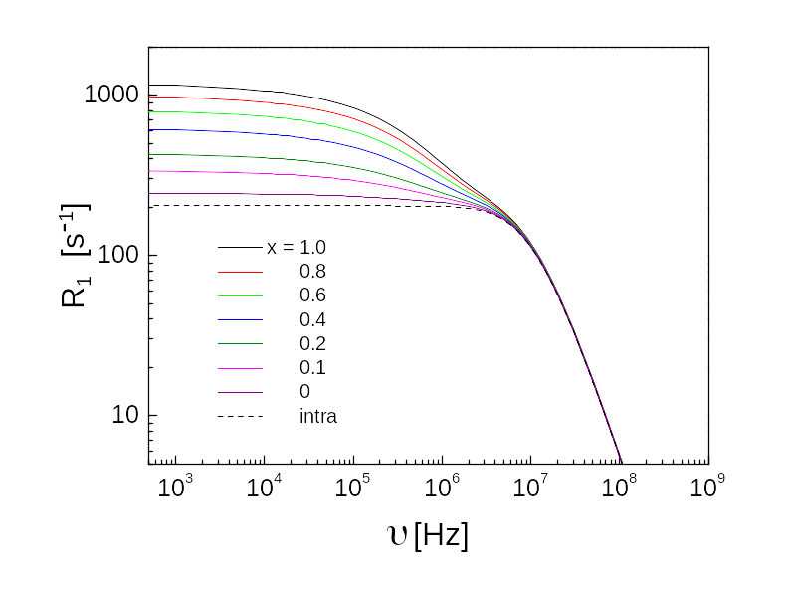
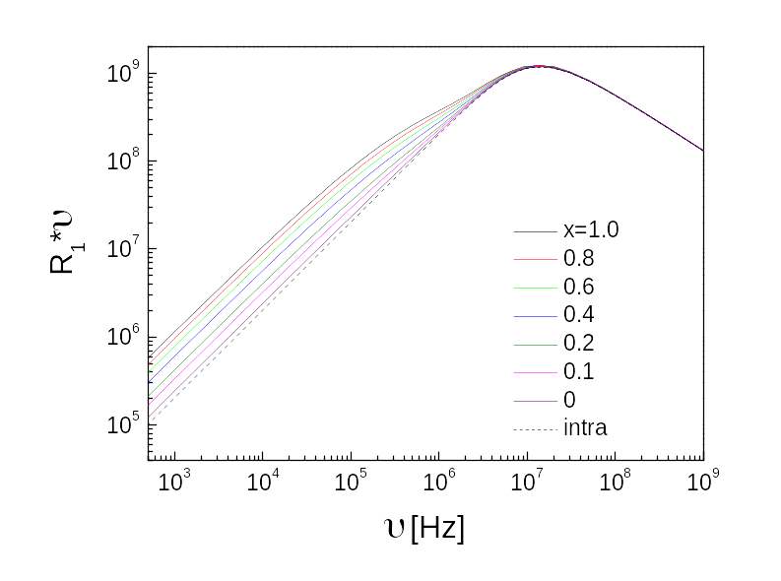

Fig. 1. Theoretical predictions for the overall relaxation dispersion for glycerol-h₈ (n = 1) dissolved in glycerol-h₀ for different mole fractions x of glycerol-h₈, according to Eq. 7. It has been assumed that 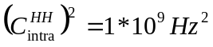, 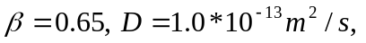 d = 3.0Å, 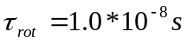.
The theoretical predictions are compared with the results of dilution experiments in Section 4. Details of the ¹H relaxation experiments for diluted systems are given in Section 3.
3. Experimental
Dispersion of ¹H spin-lattice relaxation rates, R₁=1/T₁, for glycerol-h₅ diluted in glycerol-h₀ has was studied in the temperature range of 273 K – 283 K by employing the commercial fast (electronic) field cycling spectrometer STELAR FFC 2000 ¹ which allows to cover the frequency range of 10⁴Hz -2*10⁷Hz. Spin-lattice relaxation times down to about 1 ms are accessible for the spectrometer. The temperature was controlled by heating flowing air or evaporating liquid nitrogen. The temperature stability was ± 0.3 K. In all cases a single-exponential relaxation has been observed. The measurements were done for several mole fractions of glycerol-h₅ in glycerol-h₈: x = 1.0; 0.87; 0.56; 0.30 and 0.22.

4. Intermolecular contribution to ¹H relaxation for glycerol.
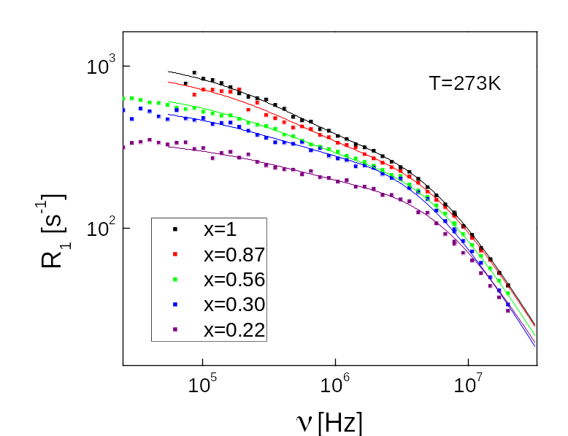
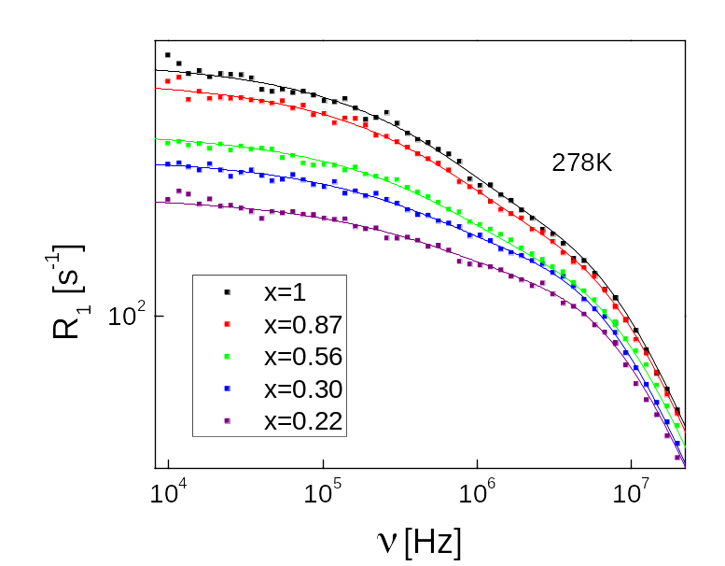
An example of relaxation dispersion data for different mole fractions of glycerol-h₅ is shown in Fig. 2. The overall relaxation rate becomes progressively smaller due to a diminishing contribution of the intermolecular relaxation. While for x = 1 one can clearly see an intermolecular contribution to the relaxation (one can notice that the relaxation dispersion contains two components), for x = 0.22 this effects is much smaller. Solid lines represent theoretical predictions (fits) which will be discussed later.

Fig. 2. Relaxation dispersion data for glycerol-h₅/glycerol-h₈ for different mole fractions, x, of the partially protonated molecules at T = 273 K (a) and T = 278 K (b). Solid lines: fits according to Eq. 9. The parameters obtained are given in Table 1.
To get a qualitative picture of the changes in the ¹H relaxation due to dilution the obtained relaxation dispersion data have been first transformed to the susceptibility representation according to the relationship: 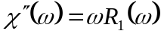. Next the susceptibility results for individual temperatures have been merged in order to construct a NMR master curve for every concentration, as shown in Fig. 3.^{2,3} The concept of constructing a master curve from individual relaxation data is based on frequency-temperature superposition (FTS), which assumes that the spectral shape of the susceptibility does not significantly change with temperature; only the time constant is different; FTS is assumed to be a generic feature of the dynamics in viscous liquids ²⁶ First a reference data set showing a maximum (in the susceptibility representation) is chosen and fitted by a CD function and then plotted as a function of 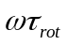. The susceptibilities for other temperatures are shifted vertically (along the frequency axis) until an overlapping is reached.
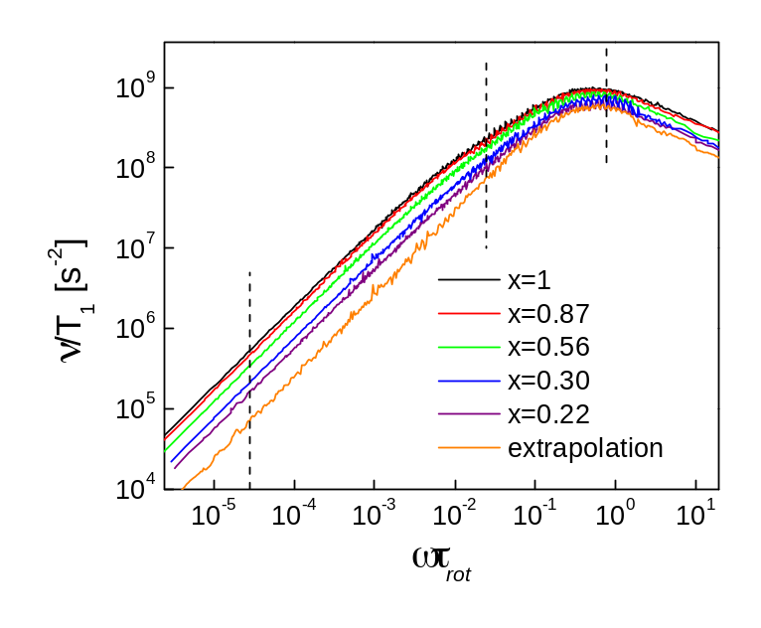
Fig. 3. NMR master curves in the susceptibility representation for glycerol-h₅ dissolved in glycerol-h₀ for different mole fractions x of glycerol-h₅; extrapolation to the zero concentration limit is included. Dashed vertical lines indicate frequencies for which x dependence is checked in Fig. 4.

To check the linear dependence of the overall relaxation rate, , on the mole fraction x, three values of have been selected; they are marked in Fig. 3 as vertical dashed lines. For these values the ratio between the relaxation rate for the concentration of x, 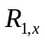, and the relaxation rate for x=1, 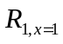, has been plotted versus x (Fig. 4) confirming the expected result.
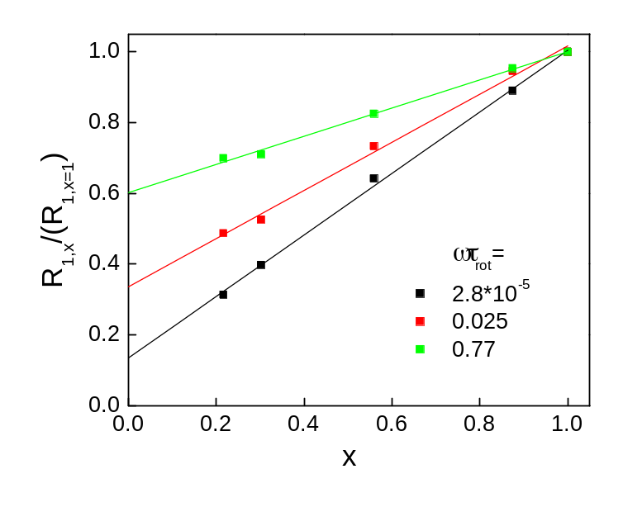

Fig. 4 / versus x for selected 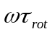 values (cf. Fig. 3).

The first observation is that the low frequency excess intensity becomes progressively less pronounced for lower x, and, eventually it disappears in the zero concentration limit. This is a direct proof of its intermolecular origin. The second observation is that even for relatively large , where according to the simulations shown in Fig. 3 one should not expect intermolecular effects, the master curves for different concentrations of glycerol-h₅ differ. This reflects the fact that there is a rotational contribution to the modulations of the intermolecular interactions.
To disclose the full spectral shape of the intermolecular relaxation the master curves shown in Fig. 3 have been extrapolated to the zero concentration limit (). In this way the intramolecular contribution to the entire relaxation has been obtained (red open spheres in Fig. 5). One should be aware at this stage that it also contains the ¹H-²H intermolecular contribution, which is, however, not significant. The intramolecular susceptibility can be well fitted by a CD function as is expected for the rotational dynamics in viscous liquids (cf. Fig. 5). Next the intramolecular master curve has been subtracted from the total relaxation () to reveal the intermolecular contribution (blue full spheres in Fig. 5). One clearly sees that the contribution of the intermolecular relaxation around the maximum of the total master curve is still significant in contrary to the theoretical predictions of the hard-sphere-force-free model according to which the intermolecular DD interactions are entirely modulated by translational diffusion. In addition this high-frequency part of the intermolecular susceptibility corresponds to the position of the intramolecular maximum. This can be interpreted as a consequence of the rotational effects on the fluctuations of the intermolecular DD couplings.

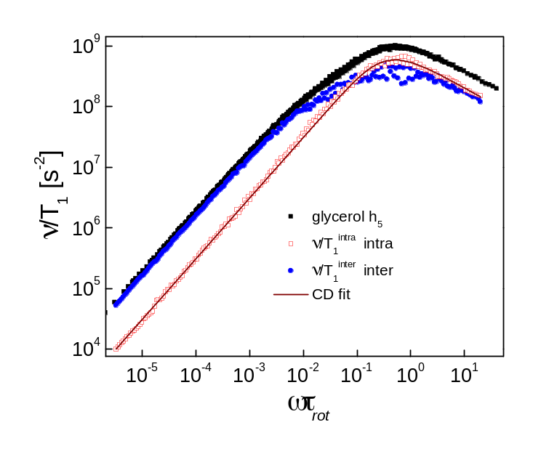Fig. 5. Decomposition of the master curve of the entire relaxation for (black squares) into intramolecular (red squares) and intermolecular (blue spheres) contributions.

To take into account the rotational effects we modify the expression for (Eq. 5) as follows:
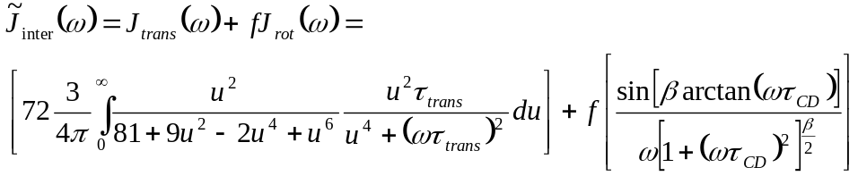 (8)
where the parameter  is a measure of the rotational contribution; 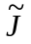indicates a non-normalized spectral density. The parameter is, in fact, related to an effective eccentricity factor ^{20,21,22} in the sense, that for centrally placed spins 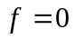 and it increases for spins more distant from the central position. This expression is a kind of simplification because it treats the translational and rotational effects on the intermolecular interactions as independent of each other. We consider it as a pragmatic way to include the rotational effects. In Fig. 6 the intermolecular master curve has been decomposed into translational and rotational parts according to Eq. 8. One notices here the relatively large contribution of the rotational part. Since the translational and rotational spectral densities of Eq. 8 are normalized, the factor 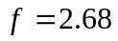 directly shows the substantial contribution of the rotational term.
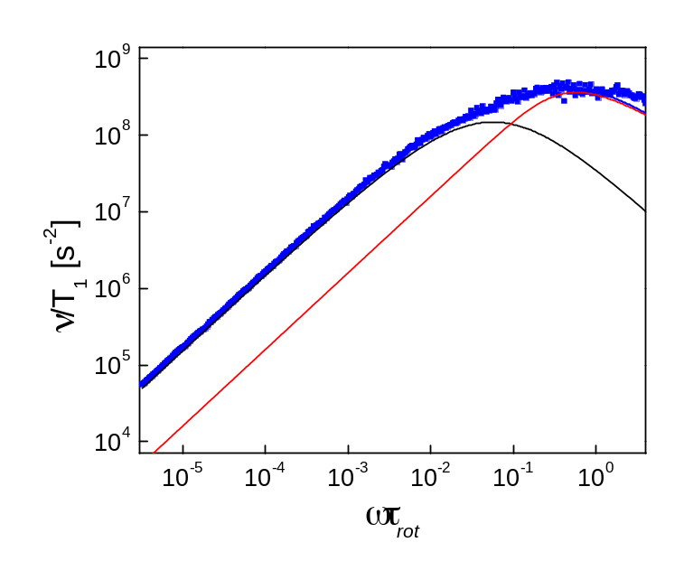

Fig. 6. Intermolecular master curve reproduced as a sum of translational (black) and rotational (red) parts according to Eq. 8.
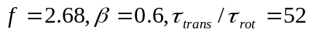

The analysis in terms of master curves reflects averaged relations between the translational and rotational parameters. To investigate in detail their temperature dependence for solutions with different dilution ratios, the individual relaxation dispersion data R₁(ν) are analyzed in the next section.

Inserting Eq. 8 into Eq. 7 one can express the total relaxation rate 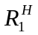 in terms of 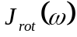 and 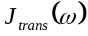:
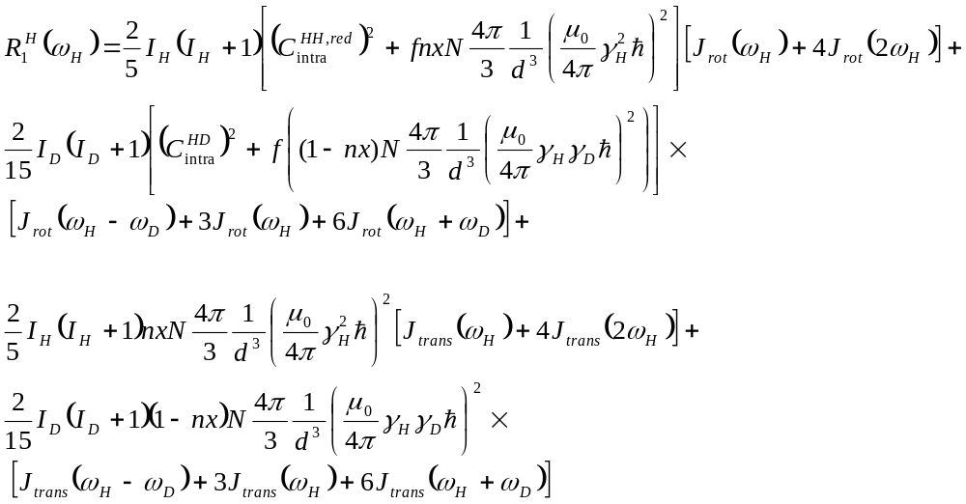(9)
This expression has been applied to interpret ¹H relaxation dispersion data for individual temperatures for glycerol-h₅/glycerol-h₀ for different mole fractions x. Examples of the analysis are shown in Fig. 7(a) and Fig. 7(b) for 275 K and 283 K, respectively. The following fitting strategy has been applied. The coupling constants and 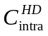 have been treated as global fit parameters for all concentrations and temperatures; the same concerns the relative contributions of the translational and rotational parts to the intermolecular spectral density, , and the distance of closest approach . The correlation time 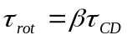 has been allowed to change depending on the temperature and concentration, the ratio 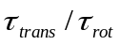 as well as  have been treated as dependent only on temperature. The same fitting strategy has been applied to the data shown in Fig. 2. The parameters obtained are summarized in Table 1.
Comparing the present results with those obtained in Ref.³ by applying solely the force-free-hard-sphere model to describe the intermolecular relaxation (that means ) one notices that now the intramolecular coupling constant 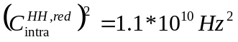is smaller than previously (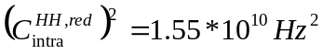) because now it has been recognized that part of the relaxation which was previously treated as intramolecular is, in fact, of the intermolecular origin.

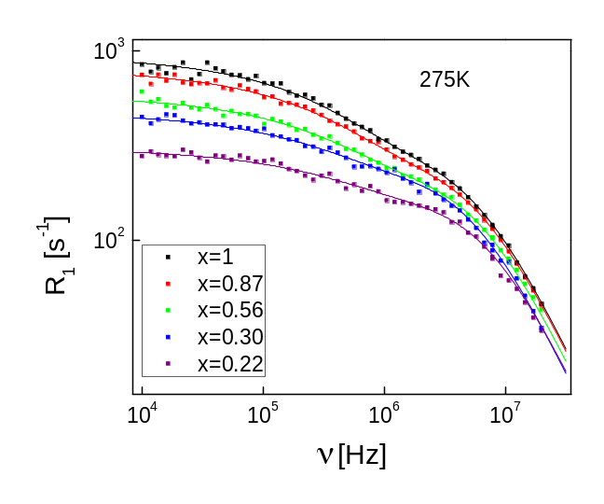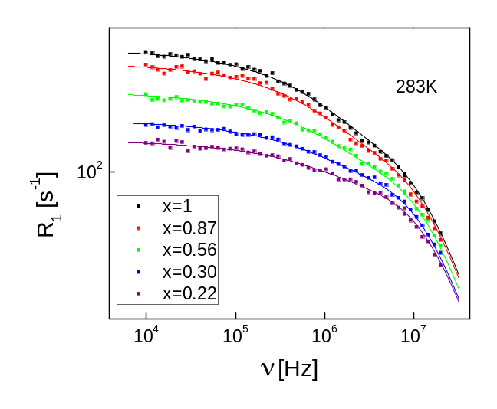

Fig. 7. Relaxation dispersion data for glycerol-h₅/glycerol-h₈ for different mole fractions of the partially protonated molecules at T = 275 K (a) and T = 283 K (b). Solid lines: fits according to Eq. 9. The parameters are given in Table 1.

Table 1. Parameters obtained by fitting the relaxation dispersion data in terms of Eq.9. The global parameters are: 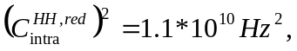 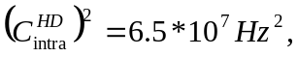 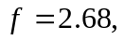 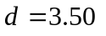Å.

T [K] | 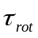 [ns]
T [K] | x=1 | x=0.87 | x=0.56 | x=0.30 | x=0.22
273 | 10.0 | 9.4 | 9.8 | 11.9 | 8.5 | 0.61 | 60
275 | 8.2 | 7.7 | 7.9 | 9.4 | 7.2 | 0.60 | 57
278 | 6.3 | 6.1 | 5.7 | 6.9 | 6.0 | 0.60 | 52
283 | 4.1 | 3.9 | 3.9 | 4.0 | 3.7 | 0.60 | 47

The obtained distance of closest approach, d, has been used to calculate the translational diffusion coefficient,  from the relationship 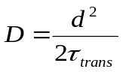. These diffusion coefficients are compared with the results of NMR pulse field gradient experiments and with the values obtained in Ref. ³ from the analysis of ¹H relaxation dispersion data under the assumption that the intermolecular interactions are entirely modulated by the translational diffusion.³ The comparison is shown in Fig. 8 (the diffusion coefficients from the current analysis are given as values averaged over all x); all results are in good agreement. In spite of the strong intermolecular rotational contribution the extracted D values are not significantly altered. One can see from Table 1 that the values of the correlation time, 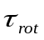, somewhat scatter with the mole fraction for a given temperature. We attribute that to temperature instability.

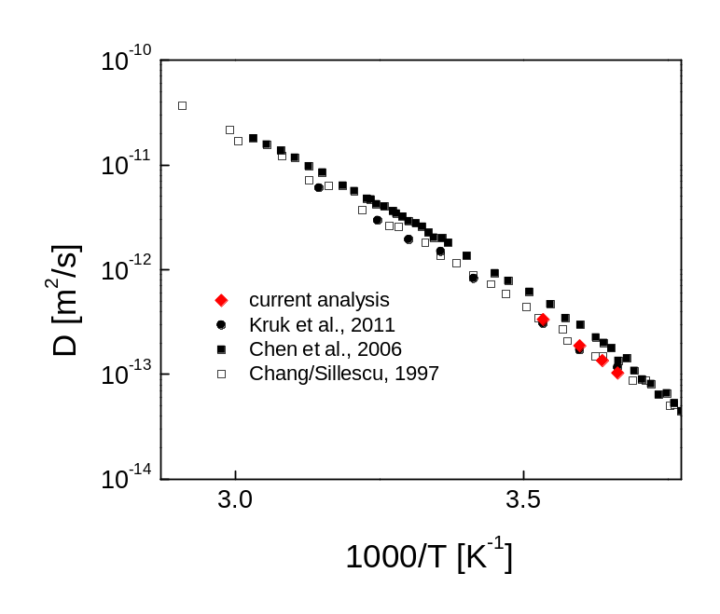

Fig. 8. Comparison of translational diffusion coefficient D obtained from pulse field gradient NMR ^{8,9} and NMR relaxometry (Kruk et al. ³ with the current analysis.

6. Discussion
As already explained, the concept of the intermolecular interactions being entirely modulated by the translational dynamics is highly simplified. Applying it for glycerol-h₈, glycerol-h₅ and glycerol-h₃ in our previous work ³ we have nevertheless obtained translational diffusion coefficients which are in good agreement with those from our present analysis and also from pulse field gradient NMR. However, the treatment of Ref. ³ has led to temperature dependent values of the distance of closest approach, . A systematic trend has been observed; for higher temperatures d became shorter. Also for glycerol-h₅ the averaged value was shorter than for glycerol-h₃. In both cases the change of d turned out to be physically not realistic. One can understand this finding as follows. ¹H nuclei in glycerol-h₃ are placed more far from the molecular center than in glycerol-h₅. In consequence, the rotational influence on the intermolecular relaxation is more pronounced; in other words the intermolecular spectral density becomes more ‘rotational-like’. A larger value reflects the fact that the relative contribution of the purely translational dynamics compared to the rotational one becomes smaller due to the increasing role of the molecular tumbling for the intermolecular relaxation. independent of f!?
The current description is also (as in Ref.³) based on a superposition of CD and translational spectral densities, but now the CD spectral density is partitioned between the intramolecular and intermolecular relaxation. This means that the weight of overall CD contribution now also depends partly on the distance of closest approach. In consequence, it was possible in the present analysis to keep temperature independent, as one expects. This indicates that using ¹H NMR relaxometry as a source of information on the translational dynamics one should consider the rotational influence on the intermolecular relaxation. This statement does not contradict the conclusion that even the simple model ^{6,7} attributing the fluctuations of the intermolecular interactions entirely to the translational motion leads to diffusion coefficients which are in a good agreement with those from pulse field gradient NMR. The reason for that is that the translational part of the intermolecular interaction is spectrally separated from the rotational contributions.
Finishing this section we note that the present approach still leads (as in ref. ³) to a temperature dependent ratio . This dependence cannot be explained by violating the rotation-translation coupling, because the trend is opposite: the obtained is smaller for higher temperatures. This suggests that this effect should be still attributed deficiencies of the applied motional models, assuming a superposition of translational and rotational components for the intermolecular spectral density.
7. Conclusions
¹H NMR relaxation dispersion studies have been performed for glycerol-h₅ diluted in glycerol-h₀ versus the mole fraction of glycerol-h₅. By extrapolating the results to the zero concentration limit the spectral shape of the intermolecular relaxation has been revealed For polyatomic molecules with nuclei at non-central positions the intermolecular DD interactions are modulated by both translational and rotational dynamics. Therefore, in addition to a contribution caused by translational motion a strong contribution associated with rotational dynamics of the molecules has been observed which clearly demonstrates the important role of eccentricity effects. Both contributions appear to be spectrally separated. The intermolecular spectral density has been described as a sum of purely translational and rotational parts. This additive model allows interpreting the relaxation dispersion data for individual temperatures as well as the NMR master curve obtained by applying FTS. Translational diffusion coefficients D(T) have been determined from the analysis based on the bimodal form of the intermolecular spectral density. The values obtained are in a good agreement with those of pulse field gradient NMR. The results also agree with the D values obtained from NMR relaxometry in our previous work ³ under the assumption that the intermolecular interactions are modulated entirely by the translational motion. Thus, regarding the determination of the diffusion coefficient this simple analysis still allows to extract reliable D values. Future work has to explain among others the variation of observed in various liquids ². Moreover, in o-terphenyl no spectrally separated intermolecular relaxation contribution is found ²; its contribution appears entirely determined by rotational motion. All in all, FC ¹H NMR with now the availability of commercial spectrometers opens new possibilities exploring the dynamics of liquids.

References
- Kimmich, R.; Anoardo, E. Progress in NMR Spectroscopy, 2004, 44, 257.
- Meier R.; Kahlau R.; Kruk, D.; Rossler E.A.J. Phys. Chem. A, 2010, 114, 7847.
- Kruk, D.; Meier, R.; Rössler, E.A. J. Phys. Chem. A, 2011, 115, 951.
- Lunkenheimer, P.; Schneider, U.; Brand, R.; Loidl, A. Contemp. Phys. 2000, 41, 15.
- Kudlik, A.; Benkhof, S.; Blochowicz, T.; Tschirwitz, C.; Rössler, E. J. Mol. Struct. 1999, 479, 201.
- Hwang L.P.; Freed J. H. J. Chem. Phys. 1975, 63, 4017.
- Ayant, Y.; Belorizky, E.; Alizon, J.; Gallice, J. J. Phys. (Paris) 1975, 36, 991.
- Chang, I.; Sillescu, H. J. Phys. Chem, 1997, 101, 8794.
- Chen, B.; Sigmund, E.E.; Halperin, W.P. Phys. Rev. Lett. 2006, 96, 145502.
- Kintzinger, J.P.; Zeidler, M.D. Ber. Bunsgens. Phys. Chem. 1972, 77, 98.
- Torrey, H.C. Phys. Rev. 1953, 92, 962.
- Abragam, A. The Principles of Nuclear Magnetism, Clarendon Press, Oxford 1961, p. 302.
- Fujara, F; Geil, B.; Sillescu, H.; Fleischer, G. Zeitschr. Physik B-Condens. Matter, 1992, 88, 195.
- Heinze, H. E.; Pfeiffer H., Zeitschrift für Physik 1966, 192, 329.
- Harmon, J. F., Chem. Phys. Letters 1970, 7, 207.
- Harmon, J. F.; Muller, B. H., Phys. Rev. 1969, 400, 182.
- Lindner, P.; Rössler, E., Sillescu, H. Makromol. Chem. 1981, 182, 3653.
- Pöschl, M.; Hertz, H. G., J. Phys. Chem. 1994, 98, 8195.
- Kehr, M.; Fatkullin, N.; Kimmich, R. J. Chem. Phys. 2007, 126, 094903.
- Ayant Y.; Belorizky E.; Fries P.; Rosset J. Journal de Physique 1977, 38, 325.
- Albrand J.P.; Taieb M.C; Fries P.H.; Belorizky E. J. Chem. Phys. 1981, 75, 2141.
- Albrand J.P.; Taieb M.C.; Fries P.H.; Belorizky E. J. Chem. Phys. 1983, 78, 5809.
- Böttcher, C.J.F.; Bordewijk, P. Theory of electric polarization., Vol. 2., Elsevier Amsterdam (1973).
- Kruk, D; Nilsson, T; Kowalewski, J. Mol. Phys. 2001, 99, 1435
- Kruk, D; Kowalewski, J. J. Chem. Phys. 2009, 130, 174104
- Götze, W. Complex Dynamics of Glass-Forming Liquids, Oxford University Press 2009

